**HTTP Request:**  
  
**Header 1: Frame**

Frame 17892 application layer data which was encrypted in the transport layer and carried over to the network layer. A header and trailer is there too, and will be sent to the destination device. Application layer

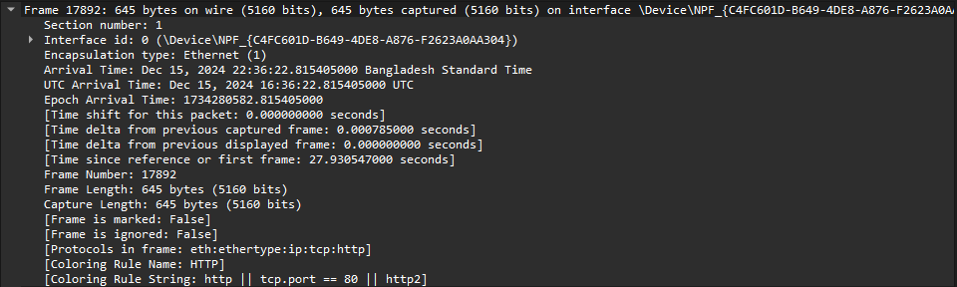

**Header 2: Ethernet**

Source and destination MAC address to identify the devices . Data link layer

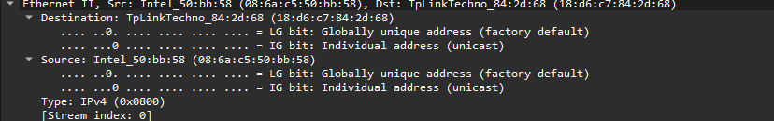

**Header 3 : Internet Protocol**

Network layer , source ip: 192.168.0.101 and destination ip :14.190.62.39 . Used for routing.

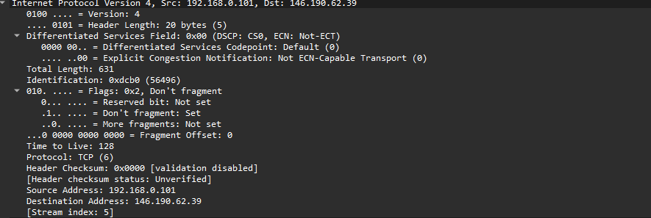

**Header 4 : Transmission Control Protocol**

Transport layer using TCP as protocol , source port 56497 to destination port 80 sequence 1, acknowledgement 1 with proper flags , it is a process to process transmission.

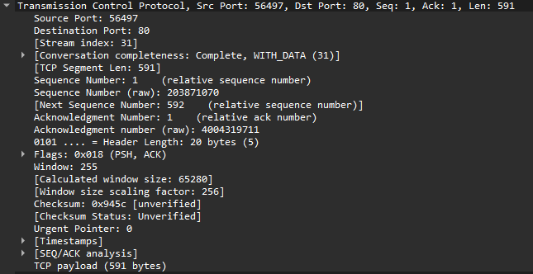

**Header 5 : Hypertext Transfer Protocol**

This GET request uses HTTP/1.1 to fetch data from httpforever.com with a persistent connection (keep-alive). Key headers include Cache-Control for freshness, User-Agent for client identification, and If-None-Match for conditional content retrieval.

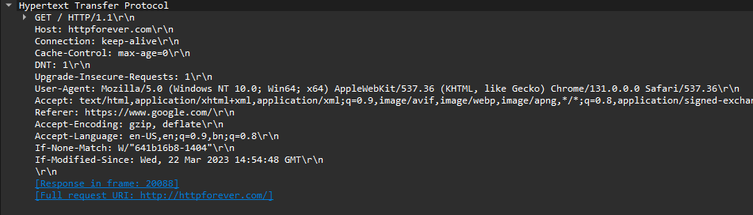

**HTTP Response :**

**Header 1: Frame**

This header indicates whether the captured packet is a response to the request. The data is from the application layer with encryptions from the transport layer.

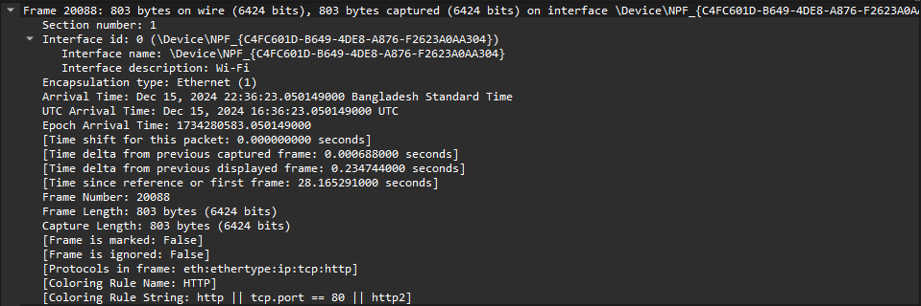

**Header 2: Ethernet**

Data link layer consists of source and destination MAC addresses.

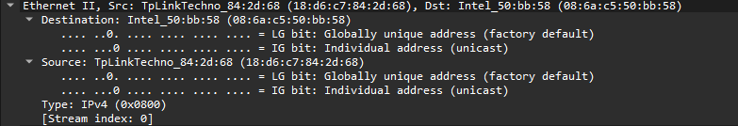

**Heder 3: Internet Protocol**

Network layer consists of source ip: 14.190.62.39 and destination ip :192.168.0.101. This header checks whether the source and destination has been accurately identified for response purpose and the delivery of information is accurate.

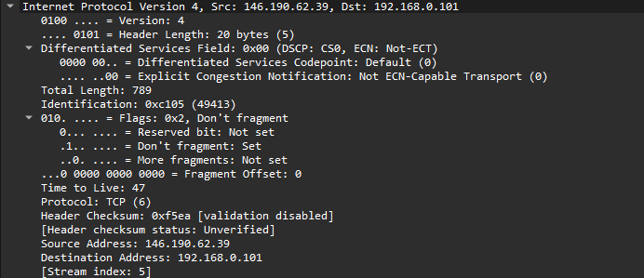

**Header 4: Transmission Control Protocol**

Transport layer using TCP as protocol , source port 80 to destination port 5697 sequence 1, acknowledgement 1 Hlen 749 with proper flags , it is a process to process transmission.

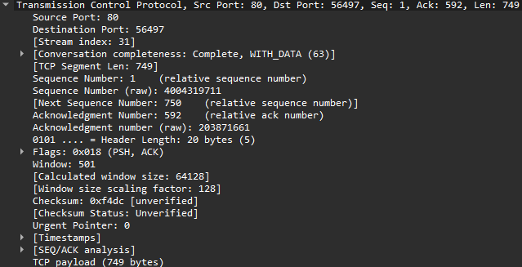

**Header 5: Hypertext Transfer Protocol**

Here, the Response Version is HTTP/1.1 with a 304 (Not Modified) status, meaning the resource hasn’t changed since the last request. The keep-alive connection persists, and headers like ETag and Last-Modified validate caching, saving bandwidth by not sending new content.

